AI Weather Wise
AI-Based Weather Information and Guidance Application
Team ID | SWTID-2026-3379
Team Size | 4
Team Leader | PREETHI L
Team Members | DEVI PRIYA S, SUMITHRA G, SIPORAL U
Date | 30 September 2026

Evidence note: The files supplied for this documentation contained only the official Naan Mudhalvan template. No project source code, screenshots, commit history or test logs were supplied. Items that cannot be proven from project evidence are therefore marked To be verified or To be measured, and team roles are proposed documentation roles. The team should update these items with real evidence before submission.

Project Description
AI Weather Wise is a weather application that gives users weather information for a location they choose, together with simple guidance on how to prepare. The user searches for a place; the application retrieves current weather and forecast data from a Weather API, processes it and shows the result along with recommendations such as whether to carry an umbrella or wear light clothing. Invalid locations and API errors are handled with clear messages, and the interface is designed to be simple and responsive on phones and laptops.
The guidance component is planned as rule-based logic that converts weather values into advice. The documentation does not claim a trained machine-learning model; ML-based forecasting and personalisation are future improvements. The frontend uses HTML, CSS and JavaScript and the backend uses Python Flask, as planned in the project brief (each To be verified against the final code).

Scenarios
Scenario 1 - Commuter checks the morning weather: A daily commuter types the name of her city before leaving. The application shows the current temperature, condition and forecast, and advises carrying an umbrella because rain is expected.
Scenario 2 - Student plans an outdoor activity: A student wants to play outdoors in the evening. The forecast and guidance indicate hot conditions and suggest light clothing and drinking water, helping the student choose a better time.
Scenario 3 - Wrong location or service problem: A user misspells the city name. Instead of a blank page, the application shows a message that the location was not found and asks the user to check the spelling. If the Weather API is unavailable, a friendly 'service unavailable' message is shown.

Technical Architecture
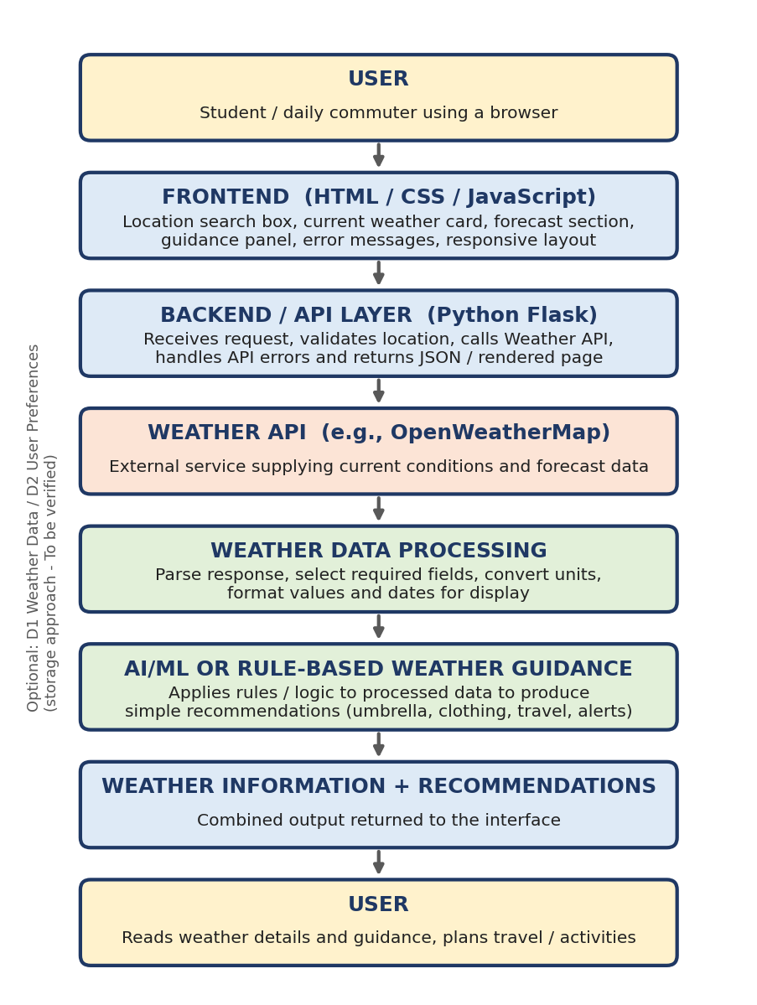
Figure 1: Technical architecture of AI Weather Wise
AI Weather Wise uses a layered architecture. The user interacts with a frontend built with HTML, CSS and JavaScript. The frontend sends the location to a Python Flask backend / API layer, which calls the Weather API, receives weather data, and passes it to a weather data processing step. The processed data goes to the AI / rule-based guidance layer, and the resulting weather information and recommendations are returned to the frontend and displayed to the user. The API key is kept in a configuration file on the server side.
No database is claimed. If the final application uses a database, an ER diagram and description must be added here.

Pre-requisites
Requirement | Purpose | Reference
Python programming basics | Backend and guidance logic | https://docs.python.org/3/
Flask framework knowledge | Backend routes and templates | https://flask.palletsprojects.com/
HTML, CSS and JavaScript skills | Frontend interface | https://www.w3schools.com/
Weather API familiarity (e.g., OpenWeatherMap) | Weather data source | https://openweathermap.org/api
Git and GitHub | Version control and submission | https://git-scm.com/doc
Code editor and web browser | Development and testing | VS Code or similar; Chrome / Edge / Firefox

Note: Exact technologies actually used in the final project are To be verified.

Project Workflow
Milestone | Description | Activities
Milestone 1: API Selection and Architecture | Select the Weather API, obtain the API key and define the architecture. | 1.1 Get a Weather API key and store it securely. 1.2 Study the API's current weather and forecast responses. 1.3 Define the architecture (frontend, backend, API, guidance). 1.4 Set up the development environment.
Milestone 2: Core Functionality Development | Build weather retrieval and data processing. | 2.1 Create the backend route to call the Weather API. 2.2 Extract and format required fields. 2.3 Handle invalid location and API errors.
Milestone 3: Weather Guidance Logic | Create recommendations from weather data. | 3.1 Define guidance rules (rain, temperature, wind). 3.2 Implement guidance functions. 3.3 Review the rules with the team.
Milestone 4: Frontend Development | Design the user interface. | 4.1 Build search box, weather card, forecast section and guidance panel. 4.2 Make the layout responsive. 4.3 Connect the frontend to the backend.
Milestone 5: Testing and Running | Test and prepare for demonstration. | 5.1 Run functional test scenarios. 5.2 Run performance checks. 5.3 Fix defects and run the application locally for the demo.
Milestone 6: Conclusion | Wrap up and document. | 6.1 Complete the documentation. 6.2 Prepare the demonstration. 6.3 List future improvements.

Installation / Setup

Milestone 1: API Selection and Architecture
Activity 1.1 - Get a Weather API key (example using OpenWeatherMap):
- Create a free account on the Weather API provider's website (for example openweathermap.org).
- Open the account's API keys section and generate a new key. Give it a clear name, such as ai-weather-wise-key.
- Copy the key. New keys can take some time to become active, so test it before the demonstration.
- Create a .env file in the project root and save the key there (example below).
- Add .env to .gitignore so the real key is never uploaded to GitHub.
# .env (example only - variable name To be verified)
WEATHER_API_KEY=your_api_key_here

# .gitignore
.env

Activity 1.2 - Study the API responses. Review the provider's documentation for the current-weather and forecast endpoints, note which fields are needed (temperature, condition, humidity, wind, rain), and check the free plan's limits. The exact endpoints used are To be verified.
Activity 1.3 - Define architecture. Follow the architecture shown in Figure 1, keeping the API key and Weather API calls in the backend.
Activity 1.4 - Set up the environment. Install Python 3 and Git, create a virtual environment (optional) and install the project dependencies.
pip install -r requirements.txt
# Expected libraries (To be verified): flask, requests, python-dotenv

How to Run
- Open a terminal in the project folder.
- Make sure the .env file contains a valid Weather API key.
- Start the application, for example: python app.py (file name To be verified).
- Open the local address shown in the terminal, commonly http://127.0.0.1:5000, in a browser.
- Type a location and press search to view current weather, forecast and guidance.
- Try an invalid location to confirm that an error message is displayed.

Project Workflow at Runtime
USER → FRONTEND → BACKEND / API LAYER → WEATHER API → WEATHER DATA PROCESSING → AI/ML OR RULE-BASED GUIDANCE → WEATHER INFORMATION + RECOMMENDATIONS → USER

API Requirements
Item | Details
Provider | Weather API such as OpenWeatherMap - To be verified
Access | Free API key from the provider (registration required)
Data needed | Current weather (temperature, condition, humidity, wind, rain) and forecast data
Format | JSON over HTTPS
Input | Location name (and units preference, if used)
Limits | Free plans have call limits - check the provider's current terms and plan
Errors to handle | Location not found, invalid or missing key, rate limit exceeded, timeout, network failure

Configuration / Environment Variables
Variable (example) | Purpose | Notes
WEATHER_API_KEY | Authenticates requests to the Weather API | Keep secret; never commit to GitHub. Actual name: To be verified
FLASK_ENV / FLASK_DEBUG (optional) | Development / debug mode | Turn debug off outside development - To be verified
PORT (optional) | Port on which the application runs | Default Flask port is commonly 5000 - To be verified

Known Limitations
- Needs internet access and a valid, active API key.
- Free API plans have call limits; heavy use may be blocked.
- Guidance is rule-based; there is no claimed trained ML model, so it does not improve forecast accuracy.
- Forecast accuracy depends entirely on the Weather API data.
- No user accounts or saved locations in the current version.
- Implementation status of each feature is To be verified by the team.

Future Improvements
- More accurate ML-based forecasting using historical data.
- Personalised weather recommendations based on user activity.
- Weather alerts and notifications.
- Multiple saved locations and comparison.
- Historical weather analysis.
- Mobile application.
- Cloud deployment with a public URL.
- Additional weather data sources for cross-checking.
Note: These are future plans and are not implemented features unless confirmed in the Functional Features document.

